support 524wifi6 DR9074 Triband card on rockchip-5b

First step, download development for rockchip-5b:
you can get source code by
git clone https://github.com/Joshua-Riek/ubuntu-rockchip
Use -ko compilation option can only build the kernel to deb, -uo can only build uboot and -ro can only build rootfs.
Then, you can move to development create you img by
./build.sh --board=rock-5b --suite=oracular --flavor=desktop

In order to support tri band cards, modifications need to be made to the kernel module.
Firstly, the ath11k_pci module needs to be added to support QCOM PCI cards. Move config.common.ubuntu to
build/linux-rockchip/debian.rockchip/config/config.common.ubuntu
in the compiled environment. This directory may not be available in the newly downloaded environment. You can compile the kernel to obtain this directory.
Move mac.c to
build/linux-rockchip/drivers/net/wireless/ath/ath11k/mac.c
Move reg.c to
build/linux-rockchip/drivers/net/wireless/ath/ath11k/reg.c
Compile the kernel so you can get a new kernel deb with ath11k_pci.

Secondly, the correct firmware of the WiFi card is also required to activate it, you can move our firmware (amss.bin, board-2.bin) to:
/lib/firmware/ath11k/QCN9074/hw1.0
and delete the amss.bin.zst and board-2.bin.zst from the directory.

Setup wireless on ubuntu

Download hostapd
you can download hostapd by use command:
sudo apt-get install hostapd

Use hostapd to create a wireless access point
First, you should turn off ubuntu’s wifi tool by this command:
sudo nmcli radio wifi off
it will block you wifi function unblock wifi by use this command:
sudo rfkill unblock wifi
You can setup an access point by using command:
sudo hostapd hostapd.conf
hostapd.config is a configuration which has set the type of wi-fi you want to enable and the following figure shows its typical structure:
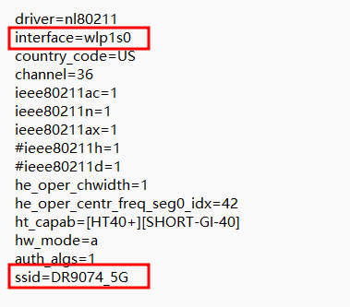
I have marked the most important part with a red box, where ssid represents the name of the wifi and interface represents the device selected to enable wifi. By the way if you don’t know your interface name, you can use command: ip addr which can show you the information about the interface, the wireless interface always seem like wlan* or wlp*.
If you see following output after you use hostapd command:
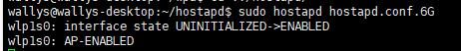
this means you have successfully started the AP.
And when you see this:
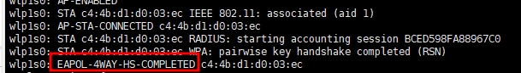
it means a device connected to you access point.
This also means connect if you not set password:
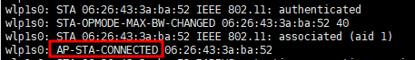

Use wpa_supplicant to connect a access point
First, you should turn off ubuntu’s wifi tool by this command:
sudo nmcli radio wifi off
it will block you wifi function unblock wifi by use this command:
sudo rfkill unblock wifi
You can connect an access point by using command:
sudo wpa_supplicant -Dnl80211 -iwlp1s0 -c wpa.conf
-i can set the interface you want to use to connect. wpa.config is a configuration which has set the type of wi-fi you want to connect and the following figure shows its typical structure:
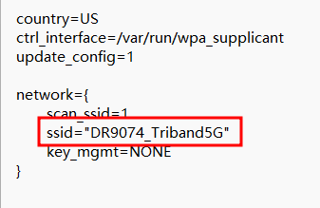
you can change the ssid to which access point you want.
If you see following output after you use hostapd command:
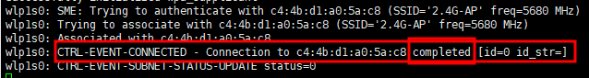
this means connect successful.
If you want to connect a access point which has a password you should change the wpa_supplicant configuration like this:
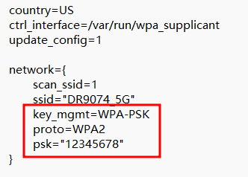
the psk is the password proto and key_mgmt is the encryption options.

FAQ
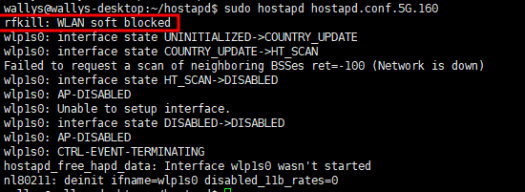
when you see this output you can use: sudo rfkill unblock wifi

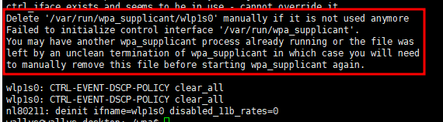
when you see this output that means you may run another wpa_supplicant, you should close it then you can run another wpa_supplicant if you don’t know where is it, you can use command: sudo killall wpa_supplicant to kill all wpa_supplicant.

